# PROCEDURE

1. Go to figma.com.

2. Sign in with your enrollment number.

3. On Figma home page click on design file.

4. Give title to your file.

EX: File is “PROTOTYPE”

Page 1: HOME PAGE.

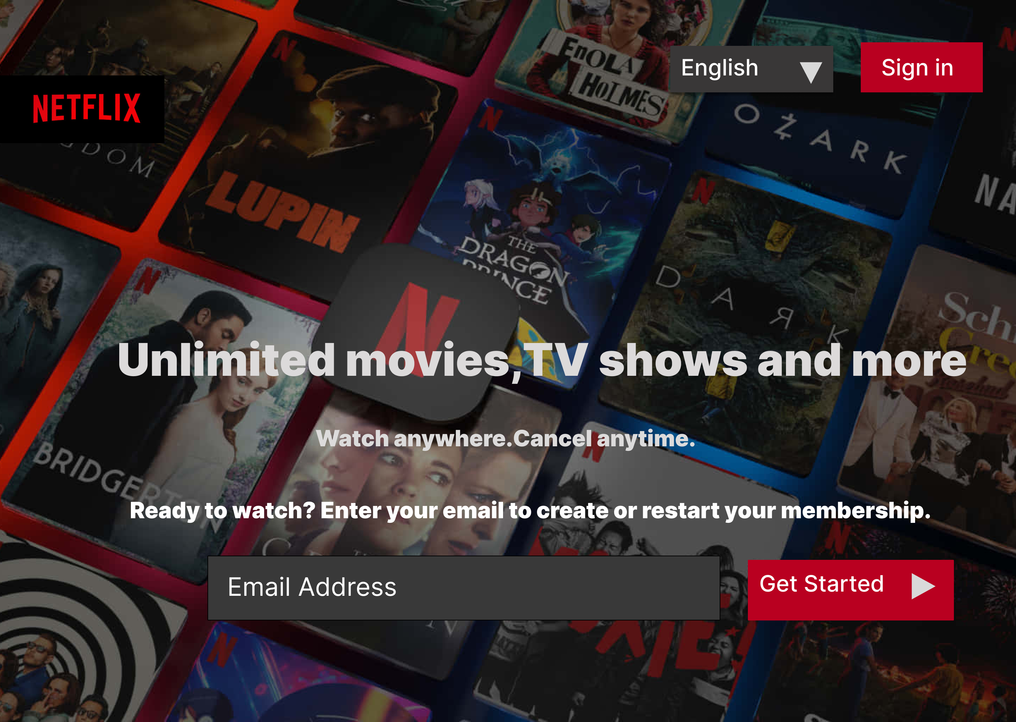

# Page 2: Sign in page

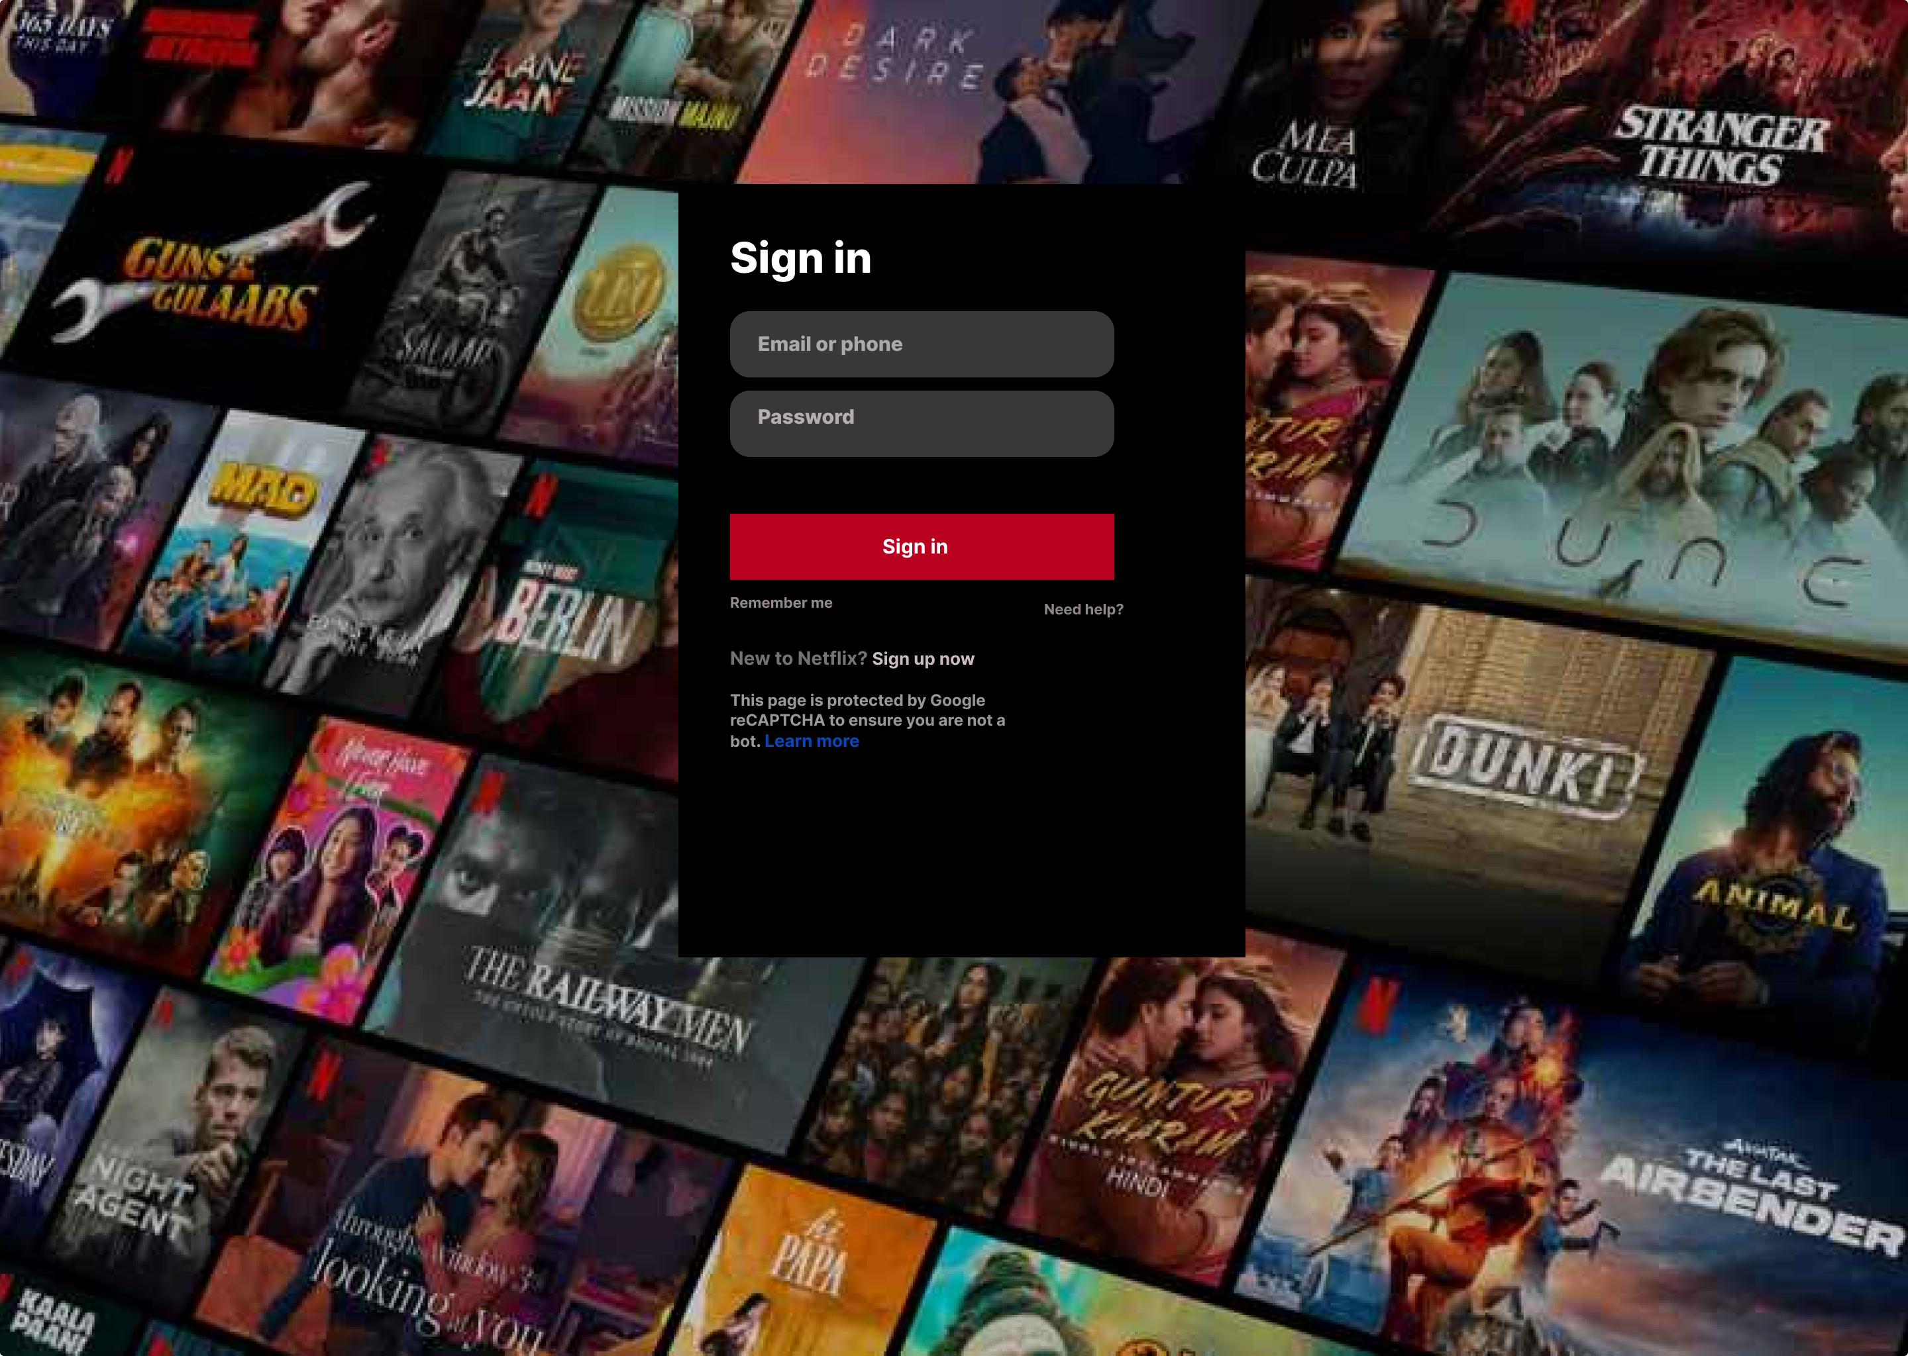

# Page 3. NETFLIX LOGO.



# Page 4.

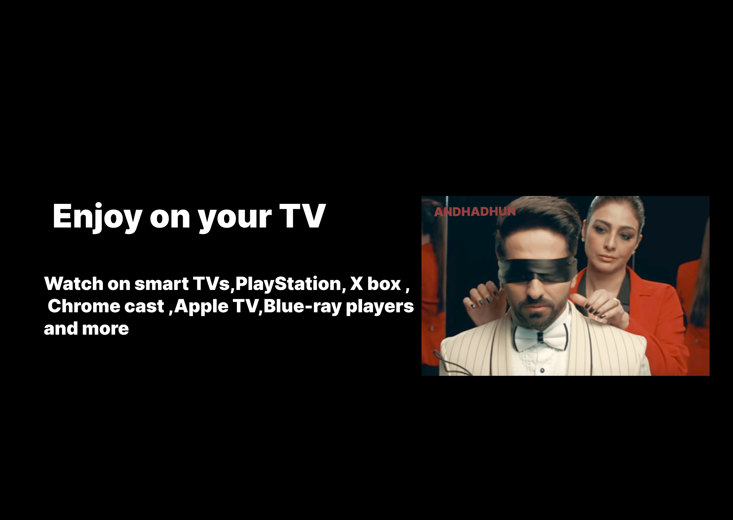

# Page 5. : AVAILABLE OFFLINE ONCE DOWNLOADED.

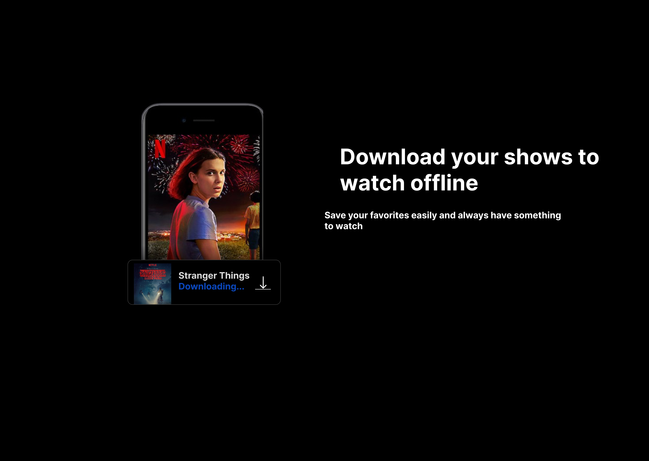

# Page 6. AVAILABILITY ON DEVICES.

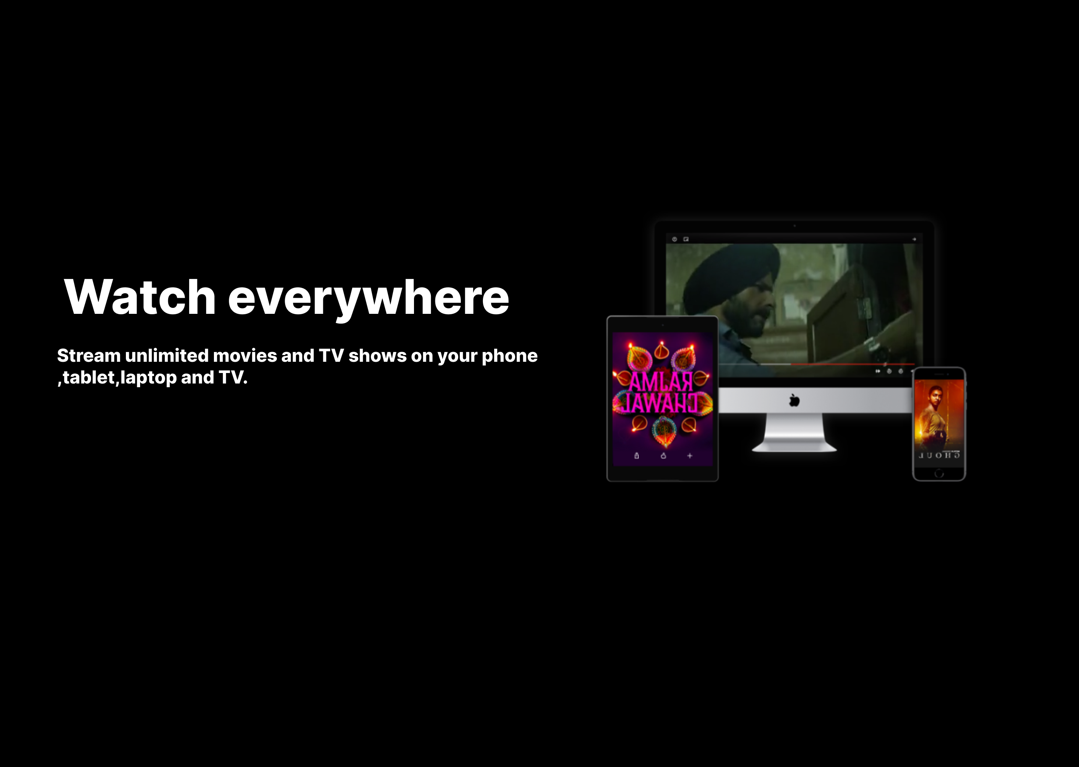

# Page 7.: PROFILE FOR CHILDREN

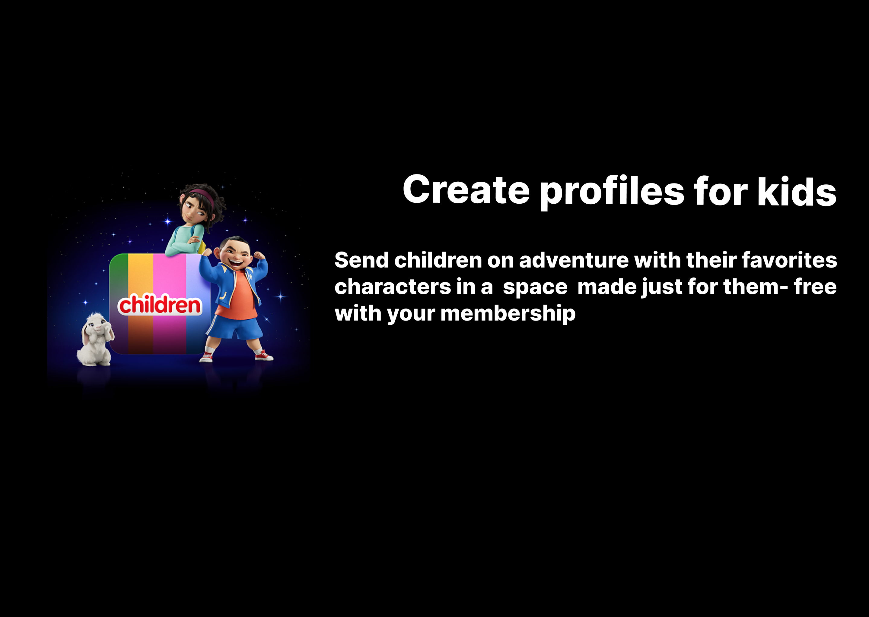

# Page 8.: QUESTIONS REGARDING NETFLIX.

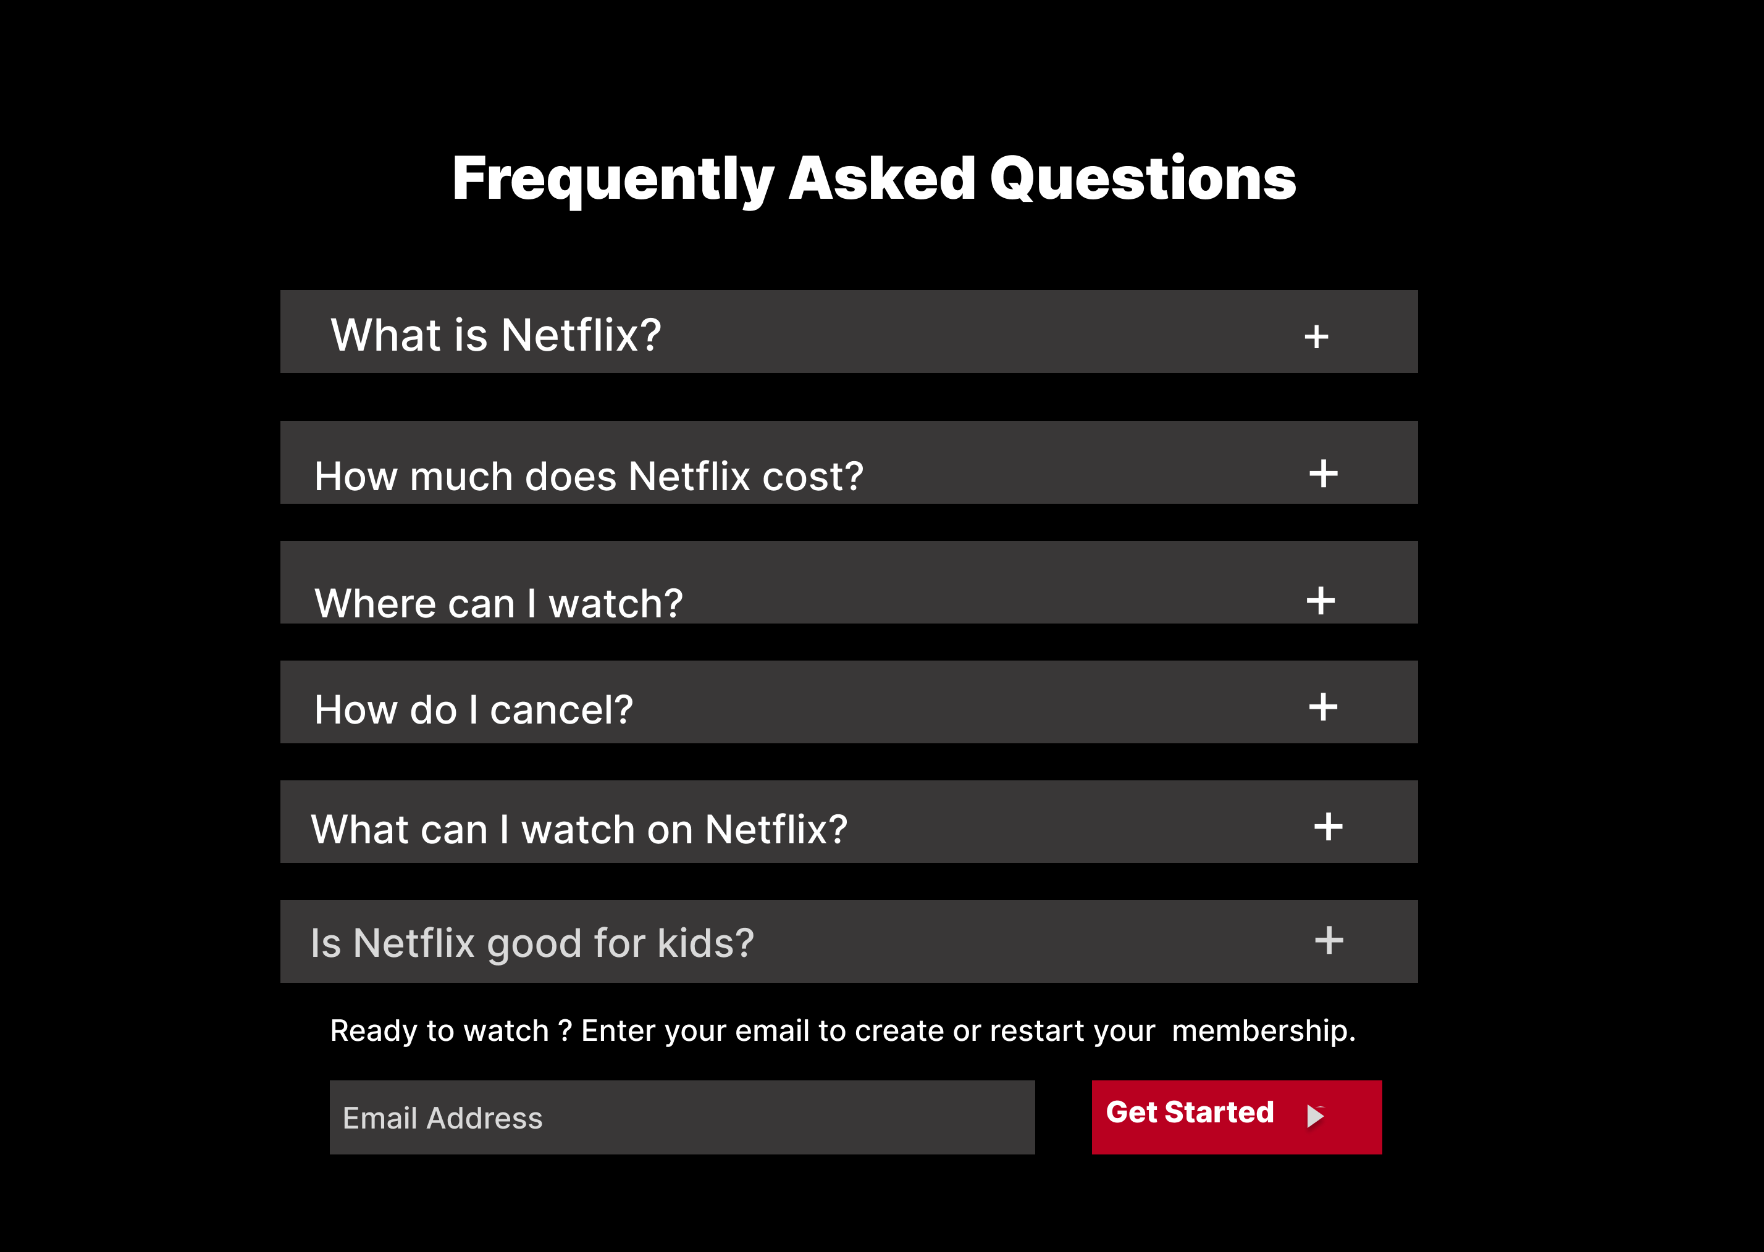

# Page 9.: HELP PAGE.

